**HEI Progress Report Form**

|  |  |
| --- | --- |
| **Principal Investigator:** | Kees de Hoogh |
| **Institution:** | Swiss Tropical and Public Health Institute |
| **Title of Study:** | Accounting for Mobility in Air Pollution Exposure Estimates in Studies on Long-Term Health Effects |
| **Progress Report (Year, Month):** | Year 1, 10 Month |
| **Current Period of Performance:** | 12/1/2020-3/31/2021 |

*(Report should be 5-10 pages, not including attachments. Please insert your text in the spaces provided below)*

**I. Brief Description of Study Aims and Design**

Large scale epidemiological studies investigating long-term health effects of air pollution can typically only consider the residential locations of the participants, thereby ignoring the space-time activity patterns that likely influence total exposure. People are mobile and can be exposed to considerably different levels of air pollution or air pollution mixtures when inside vs. outside, commuting, recreating, or working. Neglecting these mechanisms in exposure assessment may lead to incorrect distributions of exposure over the population which may lead to incorrect exposure health relations in epidemiological studies. The main aim of this study is to assess whether more sophisticated estimates of individual exposure, considering population mobility, decreases the bias in health studies.

Conducted in Switzerland and the Netherlands, MOBI-AIR will include purpose-designed tracking campaigns in both countries to capture mobility data for 2000 individuals using tracking devices. This information will be used to calibrate and validate agent-based models (ABM) in the simulation of mobility and commuting tracks for the large number of participants in the included cohort studies (SAPALDIA, EPIC-NL and the Swiss National Cohort). This study draws from our extensive collection of existing air pollution exposure models, and will include the traffic-related pollutants: NO2, BC, PM2.5, PM2.5 elemental composition and UFP. These existing models will be enhanced to produce long-term hourly estimates. Combining the ABM tracks with the detailed spatial-temporal air pollution data will enable calculation of “mobility-enhanced” exposure estimates for every individual in the cohorts. More basic exposure metrics, including the traditional (home address only) and a time-weighted (home + work address), will also be derived for comparison purposes. A dedicated exposure error evaluation, involving simulations, will also be conducted to understand the added value of the more sophisticated exposure estimates using mobility via ABM. Finally, the range of exposure estimates will be used to assess associations with select health endpoints in the three cohort studies and the influence of these changes in exposure will be evaluated.

Specifically the aims of the project are as follows:

1. To derive spatiotemporal mobility patterns that can be scaled to the general population (Task 1) via a tracking campaign (Task 2). The tracking campaign is conducted both in Switzerland and the Netherlands, on a large number of individuals, to collect mobility patterns to inform and validate agent-based modeling (ABM) exploiting routine time-activity survey data;

2. To quantify long-term individual traffic related air pollution exposures, from simple to a more sophisticated approach incorporating spatiotemporal mobility patterns, using enhanced existing modeled air pollution surfaces for NO2, Ultra Fine Particles (UFP), PM2.5 elemental composition (Cu, Fe and Zn), Black Carbon and PM2.5 (Task 3);

3. To evaluate the gain in performance of progressively sophisticated air pollution exposures by computing the exposure measurement error by: i) comparing the range of air pollution exposures from ABM with personal measurement data sets from past studies, and ii) simulating exposure error using realistic error scenarios; (Task 4) and

4. To determine whether more sophisticated air pollution exposures lead to less bias in studies on long-term health effects, though direct investigation of the associations using three large cohorts in Switzerland and the Netherlands and the different exposure estimates (Task 5).

Figure 1 shows how the different tasks link up in MOBI-AIR

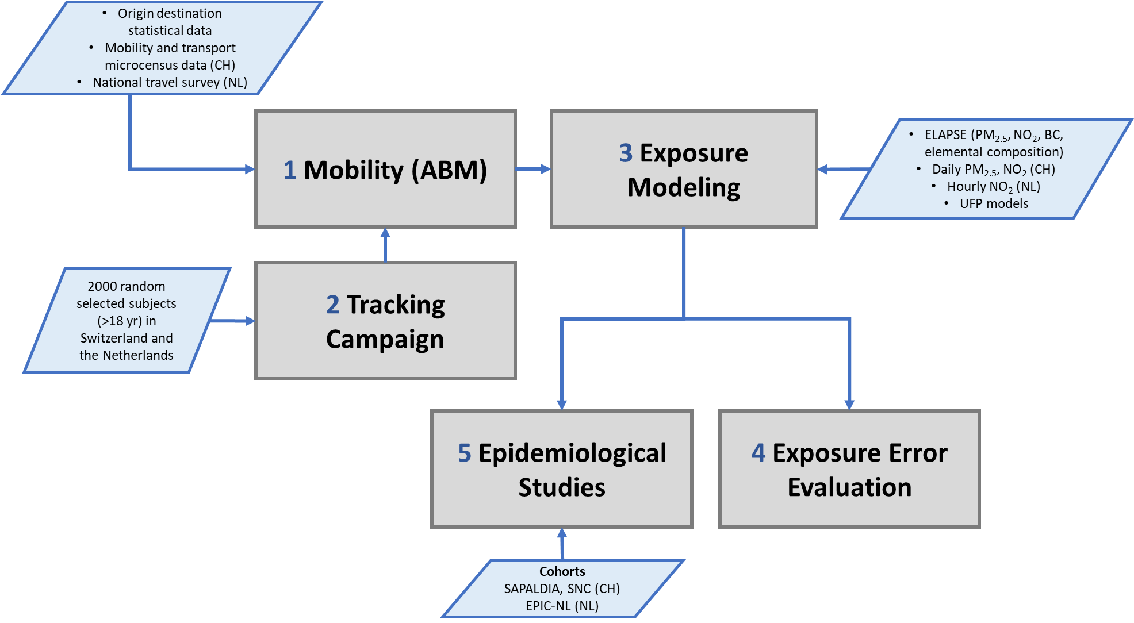

Figure 1 Design of MOBI-AIR with links between different tasks

**II. Brief Statement of Work (SOW) for Current Performance Period**

The timeline of the (sub) tasks across the 3 years is shown below. The tasks for the current performance period were in the first four quarters of year 1. Dark boxes indicate completed/in progress tasks. Due to the ongoing Covid-19 pandemic we have adapted some items, mainly related to the tracking campaigns. The full SOW (first version) is attached as an appendix.

|  |  |  |  |  |  |  |  |  |  |  |  |  |
| --- | --- | --- | --- | --- | --- | --- | --- | --- | --- | --- | --- | --- |
| Year | Year 1 | | | | Year 2 | | | | Year 3 | | | |
| Quarter | 1 | 2 | 3 | 4 | 1 | 2 | 3 | 4 | 1 | 2 | 3 | 4 |
| **1.Mobility (ABM)** |  |  |  |  |  |  |  |  |  |  |  |  |
| Obtaining input data |  |  |  |  |  |  |  |  |  |  |  |  |
| Running simulations |  |  |  |  |  |  |  |  |  |  |  |  |
| Finalizing ABM models |  |  |  |  |  |  |  |  |  |  |  |  |
| Performing sensitivity analysis |  |  |  |  |  |  |  |  |  |  |  |  |
| Apply ABM model for cohorts |  |  |  |  |  |  |  |  |  |  |  |  |
| **2.Tracking campaign** |  |  |  |  |  |  |  |  |  |  |  |  |
| Recruitment participants |  |  |  |  |  |  |  |  |  |  |  |  |
| Tracking campaign |  |  |  |  |  |  |  |  |  |  |  |  |
| Data cleaning |  |  |  |  |  |  |  |  |  |  |  |  |
| Delivering final dataset |  |  |  |  |  |  |  |  |  |  |  |  |
| **3.Exposure modeling** |  |  |  |  |  |  |  |  |  |  |  |  |
| Collecting input data |  |  |  |  |  |  |  |  |  |  |  |  |
| Temporal enhancement of existing LUR models |  |  |  |  |  |  |  |  |  |  |  |  |
| Development of hourly LUR models |  |  |  |  |  |  |  |  |  |  |  |  |
| Evaluation and selection of LUR models |  |  |  |  |  |  |  |  |  |  |  |  |
| Linking ABM output to exposure surfaces |  |  |  |  |  |  |  |  |  |  |  |  |
| Assignment exposure data to cohorts |  |  |  |  |  |  |  |  |  |  |  |  |
| **4.Exposure error simulation** |  |  |  |  |  |  |  |  |  |  |  |  |
| Generate simulation dataset |  |  |  |  |  |  |  |  |  |  |  |  |
| Running simulations |  |  |  |  |  |  |  |  |  |  |  |  |
| Evaluation of exposure error |  |  |  |  |  |  |  |  |  |  |  |  |
| **5.Epidemiological studies** |  |  |  |  |  |  |  |  |  |  |  |  |
| Writing analysis protocols |  |  |  |  |  |  |  |  |  |  |  |  |
| Writing scripts for epi analysis |  |  |  |  |  |  |  |  |  |  |  |  |
| Performing epi analysis |  |  |  |  |  |  |  |  |  |  |  |  |
| Evaluation of mobility-enhanced exposure |  |  |  |  |  |  |  |  |  |  |  |  |
| **Reporting** |  |  |  |  |  |  |  |  |  |  |  |  |
| HEI reports |  |  |  |  |  |  |  |  |  |  |  |  |
| Manuscript writing |  |  |  |  |  |  |  |  |  |  |  |  |

**III. Response to Comments or Suggestions from Research Committee** *(If any)*

From feedback letter:

“Notably, the Committee has requested that you include as much reporting as possible on pilot data from this new hybrid approach in your next progress report. They will want to be convinced of the feasibility of collecting data and utility of using data under this new approach before approving continued funding for Year 2.”

“The Committee suggests that the QA plan would benefit from advance thinking on issues including what the processes of cleaning-up the GPS data and extracting information from them will entail, and how to maximize use of this information within the limited time available. These are not trivial tasks and so need to be part of the QA plan with sufficient detail and foresight. Please send an updated QA plan as soon as possible given that the new approach is now agreed upon. Final details can be added later if necessary, but the basic plan should be in place before you start collecting data.”

*During April 2021 we have been able to test out and evaluate the feasibility of the hybrid tracking approach, using both the SODAQ tracker device and the App with reduced GPS functionality as a means to track our participants in the tracking campaign. In Section IV we report on this showing plots of routes tracked by both these methods in Switzerland and the Netherlands.*

*The main information of travel model will come from the time activity questionnaire, which is also part of the App. Here we ask the participants each day of their 2-week trial to fill in a brief questionnaire about their daily activity (see Section IV for details). We will use tried and tested R-scripts to estimate the type of travel as an extra check.*

*In light of current projections of easing restrictions due to Covid-19 we envisage a start of the tracking campaign in September 2021. This does give us a change in June 2021 to perform a pilot of the tracking campaign on a small group of people of 10 people each in Switzerland and the Netherlands. We will perform a full 2-week tracking campaign with these 20 people.*

**IV. Progress Made in Current Performance Period and Preliminary Results**

Results of evaluation of sniffer bike, track device plus App

Description input data travel surveys ABM

Results first ABM simulations

Exposure assessment – show development of daily exposure surfaces in Switzerland

Epi: analysis protocols – scripts for epi analysis

The epidemiological analysis planned for this project has overlap with the epidemiological analysis carried out in the other HEI project CLAIRE. Both projects compare the effect of using different exposure assessment methods on the health effects observed in cohorts. The cohort EPIC-NL is included in both projects and scripts and protocols written specifically for the CLAIRE project will be shared and adapted for use in MOBI-AIR. The lines between these projects are short; Gerard Hoek is the coordinator of CLAIRE and the IRAS PI in MOBI-AIR.

**V. Difficulties Encountered**

Show latest updates on mobility (Google, TomTom, Apple) during Covid-19

The Covid-19 pandemic has delayed the preparations and start of the tracking campaign. This has been compounded by a world-wide shortage/delay in electronic parts which have delayed the delivery of the expected SODAQ device tracker.

**VI. SOW for Next Performance Period** *(Include a timeline)*

**VII. Budget (for 10-month Progress Reports)** *(Attach your proposed budget and justification)*

**VIII. Other Attachments** *(Please list and attach meeting abstracts and manuscripts that were submitted or published during the performance period)*